**Homework 3: Well Transmissions**

**Quantum Mechanics II: PHYS 511**

**Gabriel M Steward**

**February 2022**

**Texts Referenced:**

**Modern Quantum Mechanics, Sakurai and Napolitano**

**Introduction to Quantum Mechanics, Griffiths and Schroeter**

**(Further references at the end)**

**The One and Only Problem**

*Show that, in spherical coordinates*

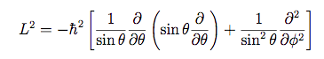

*And*

::Desktop:Screen Shot 2022-01-29 at 11.02.48 AM.png

To begin, start with the cartesian versions of everything—we don’t want to accidentially start with a spherical coordinate version of a component “already worked out” when we need to derive it.

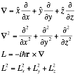

It looks like the gradient in spherical is what we need to find first, as the others rely on it. Let’s take a look at an individual derivative and try to convert it. By the chain rule:

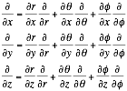

And each of the coordinates taken as derivatives with respect to each other have known values, like so:

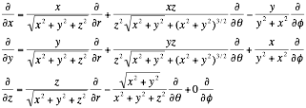

Now, all of this can be converted into spherical coordinates—either by substituting in x,y,z or directly substituting to the sphericals—for instance, r is very easy to see in the denominator here.

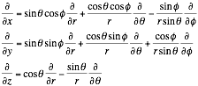

Now we insert these into the gradient—but we still have to convert the unit vectors before we can say we’re “done” here.

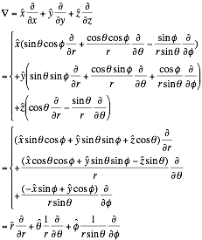

And that proves the gradient in spherical coordinates! However, this was just the first step. We must now calculate the square gradient, that is, have the gradient operate on itself.

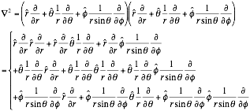

At this point we went to look up the derivatives for all the unit vectors and found a helpful document that actually had this derivation already worked out. However, we are still going to fully re-derive it here for completeness sake.

For reference, the derivatives we found were:

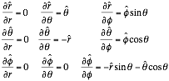

We now apply these partial derivatives.

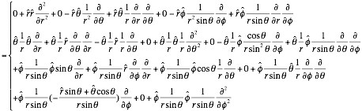

A lot of zeros is a good sign, stuff is starting to cancel out.

Now we find things that cancel and start the long simplification process.

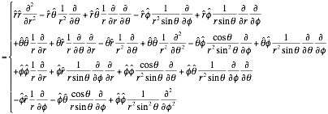

The products of the various unit vectors in spherical coordinates are now required. These can be worked out from their definitions. For cartesian coordinates, all same unit vectors multiply to 1, while all different multiply to 0 by the basic rule of dot product: **ab**=abcosθ. For identical vectors in spherical space, this is the same—like vectors become 1. But unlike vectors? Despite the fact that unit vectors in spherical coordinates move, they are *always* angled 90° away from each other, which reduces the product to zero. So our we are only concerned with the directions that are multiplied by each other, which provides

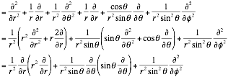

Which is, in fact, the definition of the Laplacian—but not *precisely* the form we were asked to show, for the problem statement has an L in it. Which means it’s time to move to L. Let’s work L out by itself…

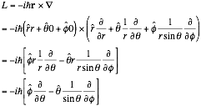

Which is what it should be.

Anyway, now we find L2.

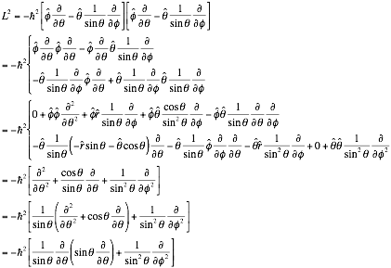

Which is *precisely* what L2 should be!

|  |
| --- |
|  |

To complete the problem, we must insert this into the Laplacian.



We think the substitution is rather obvious, which provides:

|  |
| --- |
|  |

Once again, exactly what we sought to show. With this, the problem is complete.

REFERENCES:

Vector Calculus, Fifth Edition, Jerrold E. Marsden and Anthony J. Tromba. Pg 388, Spherical Coordinate Change of Variables.

GeoGebra, graphing program, took many of the derivatives.

<https://www.google.com/url?sa=t&rct=j&q=&esrc=s&source=web&cd=&ved=2ahUKEwiWrarK2PX1AhXBGDQIHcZyBrsQFnoECAMQAQ&url=https%3A%2F%2Fwww.cpp.edu%2F~ajm%2Fmaterials%2Fdelsph.pdf&usg=AOvVaw0gEIOXV3M0rVdg0enEshQ4> further help with spherical coordinates, such as the unit vector derivatives. As it turns out this actually has the problem for the Laplacian worked out at the bottom. From cpp.edu, Cal Poly Pomona. (Why the link displays as a Google search result I’m not entirely sure, something about it being a direct pdf link most likely.)